Atmanirbhar Bharat

(Updated – Feb 2022)
PM announced the ‘Atmanirbhar Bharat Abhiyan’, on ……….. & a stimulus package — worth Rs 20 lakh crores was announced aimed towards accelerating the mission.
- The announced economic package is 10% of India’s GDP in 2019-20.
- The package is expected to focus on land, labour, liquidity and laws.

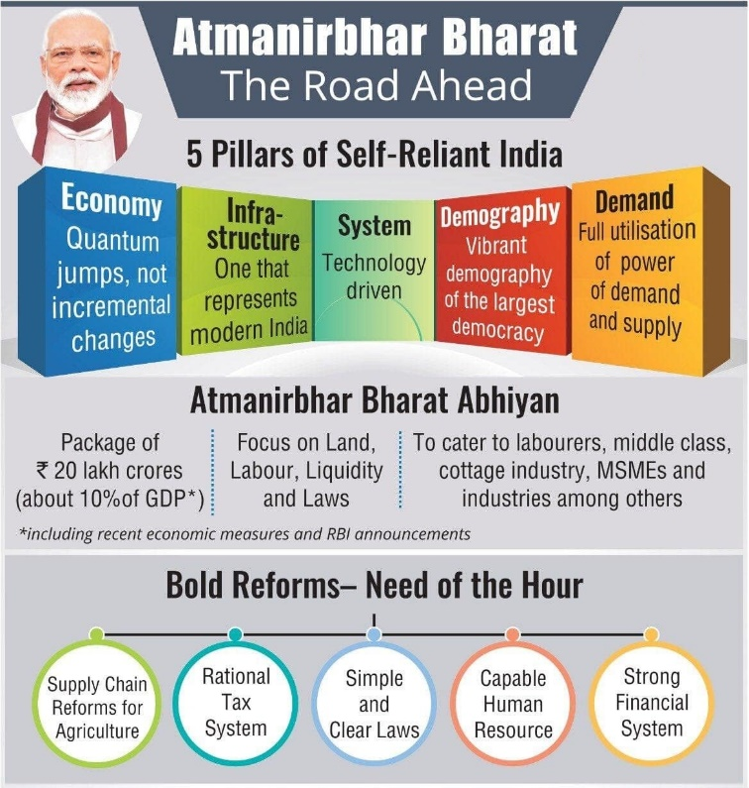
The Atma Nirbhar Bharat Mission aims towards cutting down import dependence by focussing on local substitutions, while improving its quality to gain global market share.
The Self-Reliance is neither exclusionary nor isolationist, but involves promotion of its own manufacturing capability.
- The Mission focuses on the importance of promoting “local” products. The Mission is also expected to complement ‘Make In India Initiative’ which intends to encourage manufacturing in India.
- Phases: The Mission will be carried out in two phases:
Phase 1: Will include sectors like medical textiles, electronics, plastics and toys where local manufacturing and exports can be promoted.
Phase 2: Will include products like gems and jewellery, pharma and steel, etc.
- 5 Pillars: The Mission would be based on five pillars namely,
System, Infrastructure, Demography, Demand & Economy (SIDDE)

